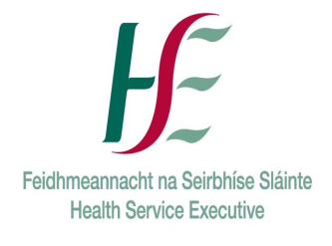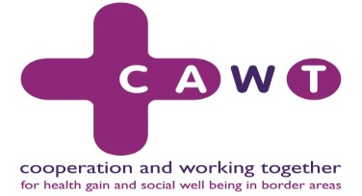

**All-Ireland Lymphoedema Conference**

**13th November 2019 – Programme**

|  |  |  |
| --- | --- | --- |
| **Timings** | **Title** | **Speaker** |
| *9.30 - 10.00am* | *Registration*  Chairs for morning session: Kay Morris and Jane Rankin | |
| 10.00 - 10.15am | Welcome | Ms Geraldine Crowley, Assistant National Director Primary Care Strategy and Planning, HSE.  Ms Jenny Keane, Chief AHP Officer N Ireland, Department of Health |
| 10.15 - 11.00am | The “Red Legs” Project and cellulitis | Keynote speaker: Ms Rebecca Elwell |
| 11.00 - 11.10am | Lymphoedema – my perspective | Ms Fiona Fraser-Brenchley, Service User, Belfast |
| 11.10 - 11.25am | The Lymphoedema Network Northern Ireland: 10 year review and 5 years forward | Ms Jane Rankin MBE, LNNI |
| *11.25 - 11.55am* | *Coffee and visit Manufacturers* |  |
| 11.55am -12.15pm | The HSE Lymphoedema update | Ms Kay Morris, Lymphoedema Project Manager, HSE |
| 12.15 - 12.40pm | Obesity and lymphoedema research project | Ms Emer O'Malley, Physiotherapist |
| 12.40 - 1.00pm | Improving prevention and management of simple oedema in primary care | Ms Pippa McCabe, Lymphoedema Lead and Ms  Vivienne Murdoch, Chronic Oedema Liaison Nurse, South Eastern Health and Social Care Trust |
| 1.00 - 1.20pm | The Healthy Legs Project (update on baseline outcomes) | Ms Gillian McConaghie and Ms Catherine McClelland, Southern Health and Social Care Trust |
| *1.20 - 2.20pm* | *Lunch and visit Manufacturers* Chair for afternoon session: Ms Jenny Keane | |
| 2.20 – 3.05pm | Red Legs Management Pathways (including ABPI vascular assessment document) | Keynote speaker: Ms Rebecca Elwell |
| 3.05 - 3.25pm | Bariatric case study | Ms Jill Lorimer, Lymphoedema Lead Belfast Health and Social Care Trust |
| 3.25 - 3.40pm | Exploring the experiences of patients with primary and secondary, non-cancer related, lower limb Lymphoedema during the intensive and maintenance phase of CDT and its impact on their lives. | Dr Mary Costello, TVN, HSE |
| 3.40 - 4.10pm | Compression Class challenges and the Drug Tariff national project | Dr Gavin Hughes, Deputy Director / Technical Manager, Surgical Materials Testing Laboratory (SMTL), NHS Wales Shared Services Partnership |
| 4.10 - 4.15pm | Summary and Close | Ms Jenny Keane |