All Ireland Lymphoedema

Patient Sticker

Child & Young People
Lymphoedema Review

Informed consent obtained No Yes
If yes, and child under 16, consent provided by:
Relationship to child:
Written consent obtained (for photographs) No Yes
Location of appointment: | Date of appointment:
 | Time of appointment:
Name of Therapist and Signature:
Name of people present:
What’s happened or any concerns since the last appointment

Any changes to medication? No Yes _________________________________________
______________________________________________________________________________
Any changes to medical history since last visit? No Yes ________________________
______________________________________________________________________________

Subjective Re-assessment
Pain: (related to lymphoedema site)
Stated as: Unable to determine None Mild Moderate Severe
Site: _________________________________________ Constant Intermittent
Description: _____________________________________ (stabbing? burning? shooting? ache?)
Pain score

0 (nothing) 10 (excruciating)
Heaviness: Unable to determine
Heaviness score
0 (nothing) 10 (excruciating)
Sensation: Unable to determine Normal
Altered Description: _______________________________________________
Cellulitis
Any cellulitis since last seen: No Yes Date: ___________________________________
If yes, how many days off work/school due to cellulitis? __________________________________
Main antibiotic given______________________Duration:________________________________
Did the cellulitis cause hospital admission? No Yes N/A
If yes number of nights as inpatient__________________________________________________
Prophylactic antibiotics? No Yes Date commenced _____________________________ No. of episodes within the last year: _______________ if 2 episodes have prophylactic antibiotics been prescribed? No Yes ____________________________________________________

Communication Function Classification System (CFCS)
(Please tick boxes below or here if child too young or N/A)
- CFCS Level I – a person independently and effectively alternates between being a sender and receiver of information with most people in most environments
- CFCS Level II – a person independently alternates between being a sender and receiver with most people in most environments but the conversation may be slower
- CFCS Level III – a person usually communicates effectively with familiar communication partners, but not unfamiliar partners, in most environments
- CFCS Level IV – the person is not always consistent at communicating with familiar communication partners
- CFCS Level V – a person is seldom able to communicate effectively even with familiar people

Gross Motor Function Classification System (GMFCS)
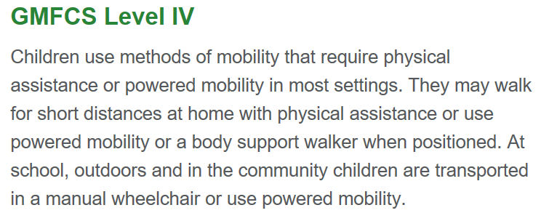
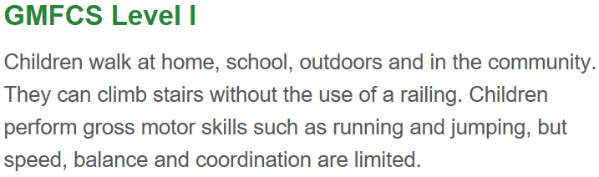
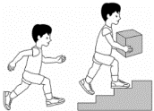
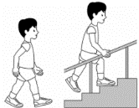
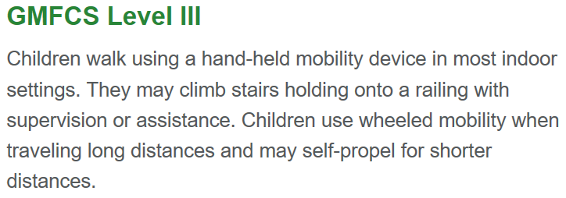
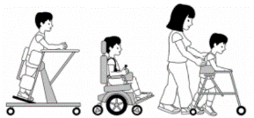

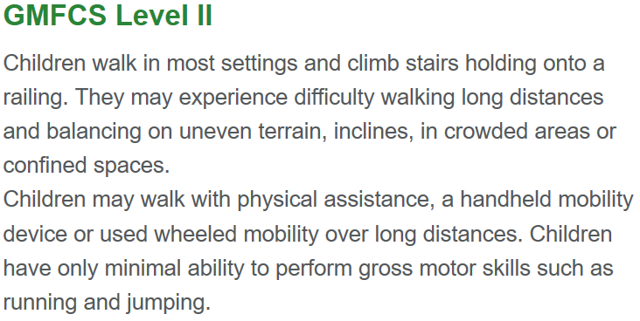

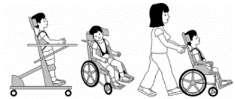
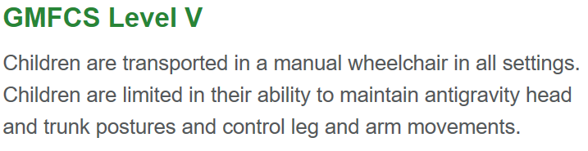

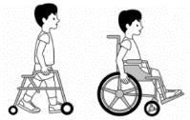

GMFCS Score

Patient Sticker

PROMS – Impact of Lymphoedema
* All the below questions relate to your  lymphoedema/vascular anomaly | None | A little | A lot | N/A
- Are you worried about your lymphoedema?*
- Does your lymphoedema* cause you pain?
- Do you have any problems moving your body?
- How much do your scars bother you?
- How much does the heaviness of your limb bother you?
- Are you worried about getting cellulitis (infection)?
- How much does the appearance of your lymphoedema* worry you?
- Does your lymphoedema* affect the clothes you wear?
- Does your lymphoedema* affect the shoes you wear?
- Does your lymphoedema* affect your hobbies?
- Does your lymphoedema* affect you attending school/work?
- Does your lymphoedema* affect relationships/friendships?
- Are you worried about wearing compression garments?
- Are you worried about your weight?
- Does your lymphoedema stop you doing any exercise?
This is not applicable for this patient (please state reason)
Any other issues causing distress (in relation to lymphoedema)? ____________________________
_______________________________________________________________________________
Using the scale shown with 0=none and 10=extremely 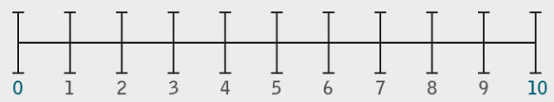
How much knowledge do you have about lymphoedema/vascular anomaly? _____________
How confident are to help your child in managing their lymphoedema/vascular anomaly? _______
Objective Lymphoedema Reassessment
Skin Assessment
Active cellulitis today? No Yes Antibiotics requested? No Yes N/A
Prescribed: No Yes N/A, if yes, prescribed by: ________________________________

Discolouration: |  | No |  | Yes | Detail: ___________________________________
Temperature: |  | Normal |  | Cold | Hot
Shape: |  | Normal |  | Distorted |  | Detail: ______________________________
 | Blisters |  | No Yes |  |  | Hyperkeratosis |  | No Yes
 | Taut |  | No Yes |  |  | Shiny |  | No Yes
 | Ulcer/wound |  | No Yes |  |  | Lymphorrhoea |  | No Yes
 | Skin folds |  | No Yes |  |  | Fibrosis |  | No Yes
 | Fatty |  | No Yes |  |  | Fungal infection |  | No Yes
 | Eczema |  | No Yes |  |  | Rash |  | No Yes
 | Seroma |  | No Yes |  |  | Cording |  | No Yes
 | Papillamatosis |  | No Yes |  |  | Warts |  | No Yes
Haemosidirin staining |  |  | No Yes |  |  | Other _________________________________
Tests (please identify on body charts)
Pitting Test |  | Positive | Negative
Stemmers sign: |  | Positive | Negative
Pain at night or at rest: |  | No | Yes | N/A
Intermittent claudication: |  | No | Yes | N/A
Capillary refill: ___________ |  | (normal is < 3 sec)
Blanching on elevation: |  | No | Yes | N/A
Vascular assessment required: |  | No | Yes | N/A
Range of Movement (ROM)
 |  | RIGHT |  |  |  |  | LEFT
 |  | 100% | 75% | 50% | 25% | 0% | 100% | 75% | 50% | 25% | 0%
Shoulder | Hip
Elbow | Knee
Wrist | Ankle
Fingers | Toes
Functional Impact:

Were circumferential measurements captured & recorded? No Yes, reason why not ______
______________________________________________________________________________
Was weight captured & recorded? No Yes, reason why not ________________________
Was height captured & recorded? No Yes, reason why not ________________________ Was BMI captured & recorded? No Yes, reason why not ________________________
Consider growth percentile changes:

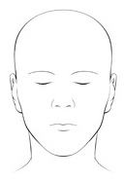
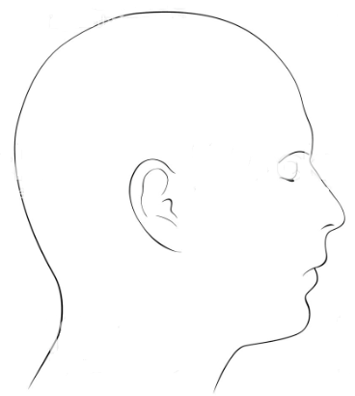
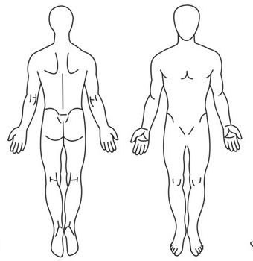
Body Chart

Patient Sticker

Photo taken:
No | Yes

Reassessment findings:
What are the therapist’s main concerns/issues today?

What are the child’s/ young person’s goals/hopes/aspirations?

What are the parent/ carer goals/hopes/aspirations? (if applicable)
Agreed combined goal:
Education, Advice and Lymphoedema Care Plan
Education, Advice and Lymphoedema care Plan
The patient/parent/carer has agreed to continue with the following actions:
Skin care: ___________________________________________________________________
______________________________________________________________________________
Movement/exercise: ___________________________________________________________
______________________________________________________________________________
Compression garment required: No Yes; Details of garment: ________________________
Was garment: provided or ordered __________________________________________
Compression advice: __________________________________________________________
Weight/Lifestyle: ______________________________________________________________
______________________________________________________________________________ Simple Lymphatic Drainage: _____________________________________________________
Intensive Treatment: Please tick if the following is needed
Decongestive Lymphatic Therapy Multi-Layer Lymphoedema Bandaging LymphAssist
Manual Lymphatic Drainage Manual Therapy/Scar Management
Electrotherapy (Physiotouch/Oscillator/Laser)
Detail:______________________________________________________________________________________________________________________________________________________

Referral to other service required? No Yes to: ______________ Completed? No Yes
Letter to patient/parent/carer copying in GP: No Yes, if No reason____________________
Patient Information Given:
LNW leaflets issued No Yes; LNW video links issued No Yes
Outcome of Lymphoedema Review
Patient discharged. No Yes, Discharge code _________________
If no what is the agreed timeframe to be seen again within?
Within 6 months Within 12 months Book in for Intensive Treatment

Factors Affecting the Outcome of Treatment
Vascular complications No Yes Mobility problems No Yes
Lack of support No Yes Recurrent cellulitis No Yes
Pain No Yes Progressive co-morbidities No Yes
Excess body weight No Yes Cognitive impairment No Yes
Ability to don/doff garments No Yes Sedentary lifestyle No Yes
Functional problems No Yes Chronic skin condition No Yes
Psychosocial No Yes Sleeping in chair No Yes

LNW Outcome
1 At Risk | 2 Mild | 3 Moderate | 4 Severe | 5 Complex | 5W Complex  with wound
ISL Grouping
Stage 0 Stage 1 Stage 2 Stage 3
(Latency) (mild/pitting) (Moderate/non-pitting) (Complex/fibrosis/skin changes)

BLS Grouping
Group 0 – Latent (at high risk) |  | Group 3.1 – Complex LO: one limb
Group 1 – Early Lymphoedema |  | Group 3.2 – Complex LO: multiple limbs
Group 2 – Uncomplicated (established) LO |  | Group 3.3 – Complex midline LO
 |  | Group 4 - Palliative

Print Name: Date: ___________
Therapist Signature: Time:
Time in units(TIU) |  | TIU total: |  | Total number of treatments: |  | Date of next appointment:

Patient Sticker

Actions & Communications Since Last Appointment

