- First, download the app from the LNNI website and download it to an easy-to-find location on your computer (like your desktop).
- Before you can install it on your phone you will need to make sure that third-party apps are allowed on your device.
- Go to Menu > Settings > Security > and check Unknown Sources to allow your phone to install apps from sources other than the Google Play Store.
- Android 8 Oreo and 9 Pie do things a little differently. Rather than check a global setting to allow installation from unknown sources, you'll be you'll be prompted to allow your browser or file manager to install APKs the first time you attempt to do so.
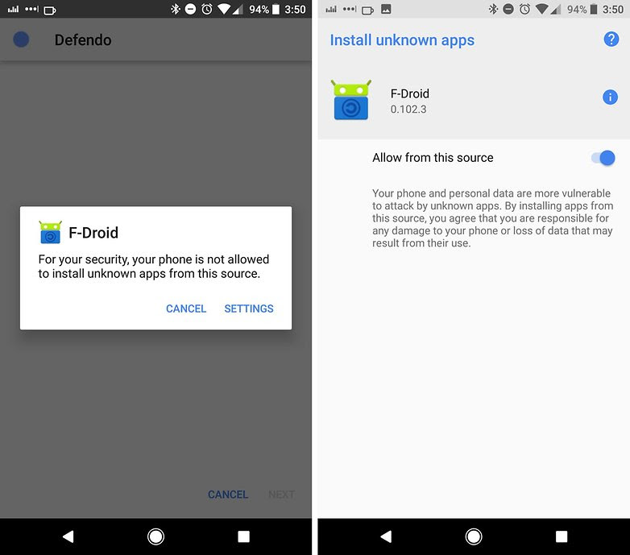When you first install from a non-Google source on newer Android versions, you see a prompt like this. / © AndroidPIT
- If you like, you can also download a file manager app so you can easily find files on your Android device. We recommend our favorite file managers in our list of the best file explorers for Android.
- Once you've downloaded the APK file on your computer, connect your Android device to it.
- At this point, you may be asked if you want to charge your phone or connect it as a 'media device.' Choose Media device.
- Then, find your phone's folder on your computer. It will be in 'My Computer' or 'Computer' on Windows (PC).
- Copy the APK file into a folder of your choice in your Android smartphone.
- You will now be able to search for the file location in the My files folder of your device.
- Find the APK file, tap it, then hit Install.
And now you're done, congratulations, you have your app.

